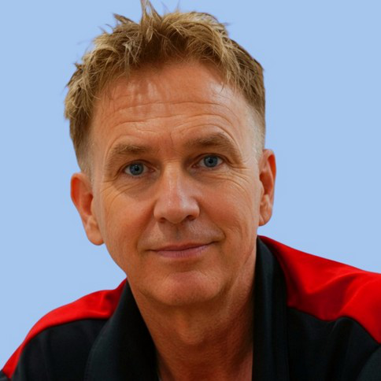  CONTACT  Kokomo, Indiana  Current Local Base  Springfield, Illinois  Venice, Florida  Global Availability  941-275-9824  tony.turasky@rocketmail.com  CREDENTIALS  • Certified Food Safety Manager - NRFSP, valid through 2031  • FEMA IS-100 - Incident Command System  • A.A.S. in Surveying, Mapping & Construction Layout  • Valid U.S. Passport - through 2033  • Valid Florida Driver License - through 2033  • $2M general liability available for contract assignments  AVAILABILITY  • Local work in Kokomo and surrounding areas  • Direct employment: full-time, part-time, temporary, or seasonal  • Independent project work through XGEN General Services LLC  • Short- or long-term assignments  • Rotational, live-in, domestic, or international deployment  CAREER HIGHLIGHTS  • 25+ years business ownership  • Illinois State and National Guard contracts  • Illinois State Fair and major public-event operations  • Five-room banquet facility operator / exclusive caterer  • Survey crew leadership and construction layout  WORKING STYLE  • Lead by example and hands-on participation  • Calm under pressure and changing conditions  • Comfortable entering unfamiliar environments  • Strong follow-through from setup through closeout  AFFILIATIONS  Elks • Moose • American Legion • VFW  Firefighters/Postal Lake Club  (Elected Board Member - 2 Years)    xgenservices.net  Credentials • portfolio • business documents  Florida-registered single-member LLC | ANTHONY TURASKY  OPERATIONS • LOGISTICS • EVENT & FIELD SUPPORT  EMPLOYMENT / CONTRACT PROFILE  CURRENTLY SEEKING LOCAL WORK IN KOKOMO • ALSO AVAILABLE FOR DEPLOYMENT  XGEN General Services LLC is my Florida-registered single-member LLC, established so I can work either as a direct employee or as an insured independent contractor for a defined project or assignment. I am open to local employment, project-based work, temporary operations support, and domestic or international assignments. Business registration, insurance, and tax credentials are available upon request or at xgenservices.net/identity.  PROFESSIONAL PROFILE  Practical operations professional with 25+ years of experience building businesses, managing kitchens and venues, coordinating events, leading field crews, and solving real-world logistical problems. Strongest in assignments that require someone to arrive early, organize the site, establish workable systems, support incoming teams, keep operations moving, and remain through transition or closeout.  PROJECT SUPPORT CAPABILITIES  • Event, site, and temporary-facility setup for weddings, public events, field teams, mobile kitchens, camps, and support operations.  • Operational logistics: purchasing, inventory, vendors, transport, equipment, scheduling, staffing, and day-of execution.  • Field liaison and professional representative for clients, contractors, local teams, and organizational leadership.  • Hands-on implementation support that helps teams adopt new procedures and operational standards through direct example.  • Advance work, startup support, workflow stabilization, transition, pack-down, and assignment closeout.  SELECTED EXPERIENCE  Kitchen Staff | 2025-2026  EverTrue / Concordia Village Senior Living & Care Center - Illinois  • Prepared meals for Assisted Living and Care Center residents, including therapeutic, modified-texture, and specialized diets.  • Supported daily production, sanitation, resident service, and cross-coverage in a structured healthcare food-service environment.  Kitchen Lead - Prepared Foods | 2024-2025  Earth Fare - Charleston, South Carolina  • Planned and produced fresh hot and cold prepared foods using natural, organic, vegetarian, and specialty ingredients.  • Managed daily production flow, ingredient information, presentation, food safety, and customer-facing service.  Owner / Operator | 1999-2024  Turasky's Catering - Illinois  • Built and operated a 25-year catering and event business serving private clients, state agencies, the Illinois National Guard, and major public events.  • Directed mobile kitchens, food production, staffing, purchasing, transport, setup, service, breakdown, and live-event problem solving.  • Selected for major Illinois State Fair and AMA Springfield Mile food-and-beverage operations serving thousands of guests.  Banquet Facility Operator / Exclusive Caterer | 2022-2023  State House Inn - Springfield, Illinois  • Leased and operated five banquet and event rooms while serving as the hotel's exclusive caterer; coordinated bookings, production, staffing, setup, service, and event execution.  • The arrangement concluded following the sale of the hotel.  Owner / Operator | 2000-2023  Trail's End Saloon - Illinois  • Built and managed a bar, grill, music venue, and private-event operation from the ground up.  Survey Crew Chief | 5 Years  Martin Engineering Company - Illinois  • Led field crews performing construction layout, boundary, and topographic work; developed strong field judgment, coordination, and independent problem solving.  CURRENT INTERESTS  Local employment • Operations support • Event setup and management • Project-based assignments • Hospitality and camp operations • Survey / field assistance • NGO, humanitarian, missionary, and disaster-response support • Domestic or international deployment    XGEN General Services LLC • Florida-Registered Single-Member LLC

